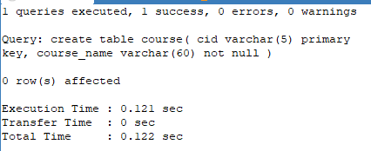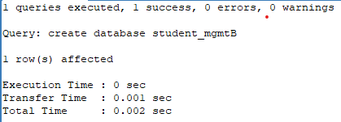

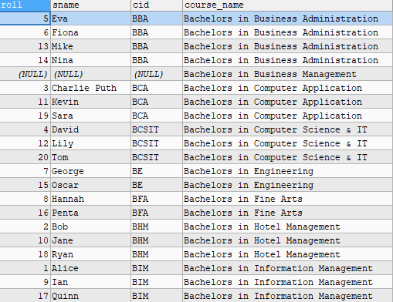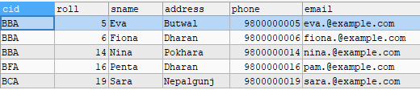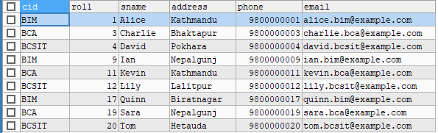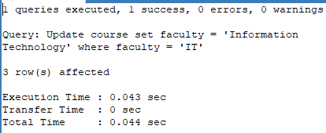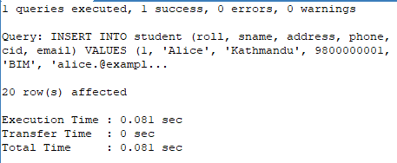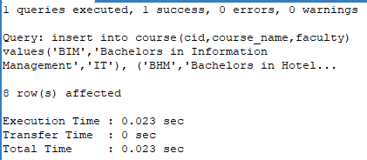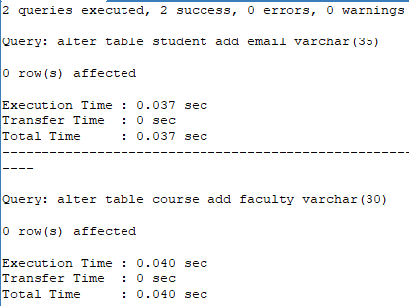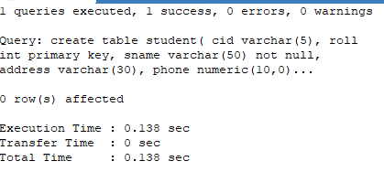

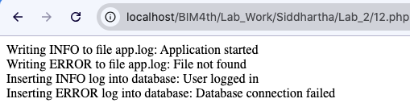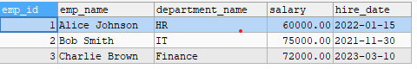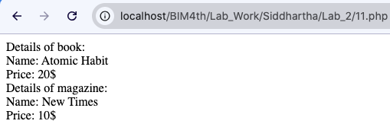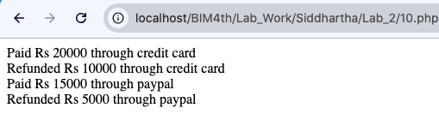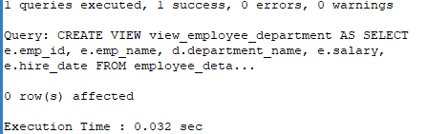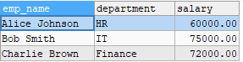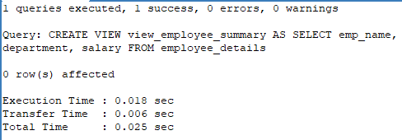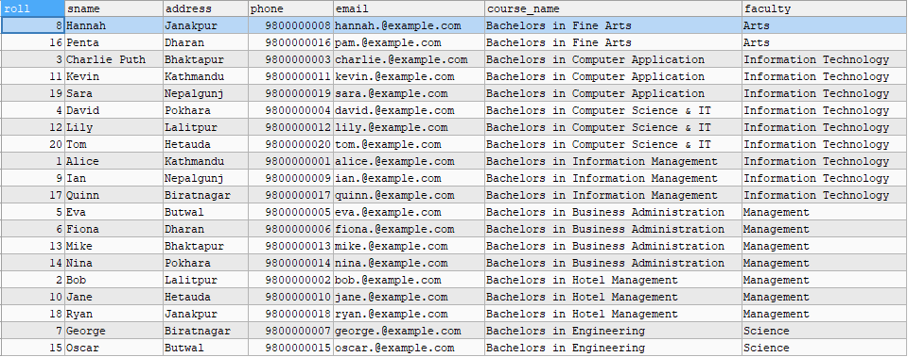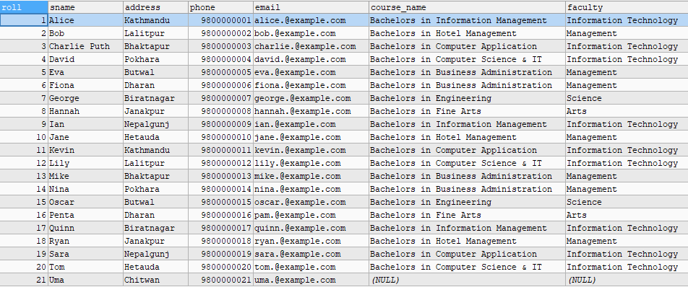

**National College of Computer Studies**

**Paknajol, Kathmandu**

Lab Report No. 2

**Database Management System**

**Submitted by:**  **Submitted to:**

Name: Siddhartha Shakya Shrija Shrestha

Program: BIM Yachu Shakya

Roll no: 19

Section: B

**Date of submission:** 2025/09/03

**National College of Computer Studies**

**Paknajol, Kathmandu**

Lab Report

On

**Business Data Communication and Networking**

**Submitted by:**  **Submitted to:**

Name: Siddhartha Shakya Pratiksha Poudel

Program: BIM Shrija Shrestha

Roll no: 19

Section: B

**Date of submission:** 2025/09/03

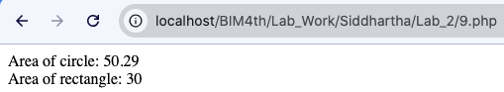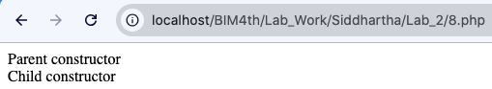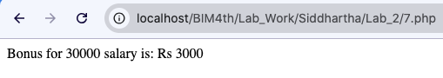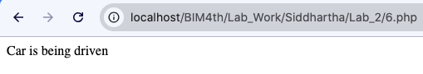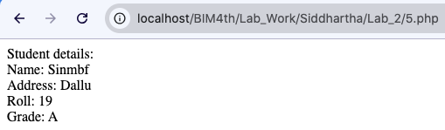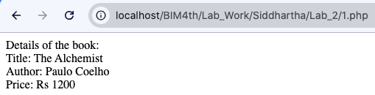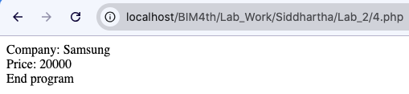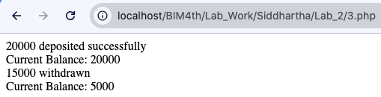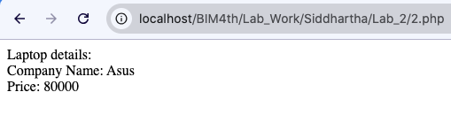

**National College of Computer Studies**

**Paknajol, Kathmandu**

Lab Report No. 2

**Web Technology II**

**Submitted by:**  **Submitted to:**

Name: Siddhartha Shakya Radha Krishna Gajurel

Program: BIM Shrija Shrestha

Roll no: 19

Section: B

**Date of submission:** 2025/09/04